**We are cross validataions code sample.**

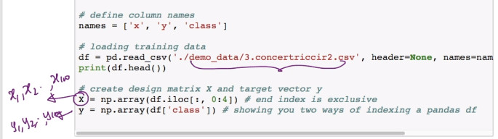

**Using concentric circle data set and and than converting it into array.**

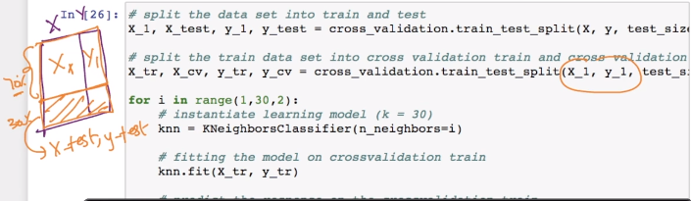

**Then dividing our data set in 70-30 ratio for train and test**

**And then again dividing that 70% data in two parts in 70-30 ratio.**

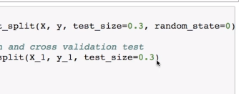

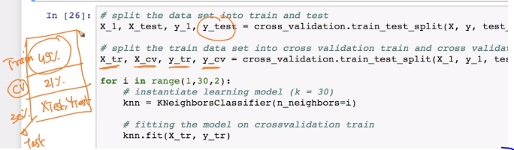

**Now for finding best K value.**

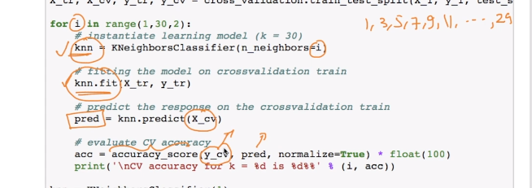

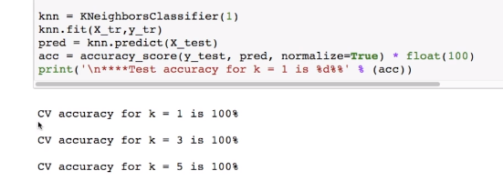

**Accuracy for K=1 itself is very high and so we will use k =1 and will .fit for train data and predict on y_test.**

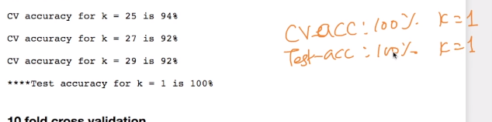

**We got test accuracy also 100% for value K = 1. This is like best case. ☺**

**Now we will see it for 10-fold cross validation.**

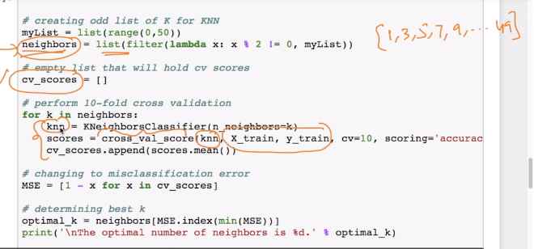

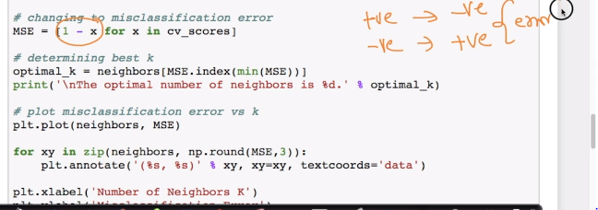

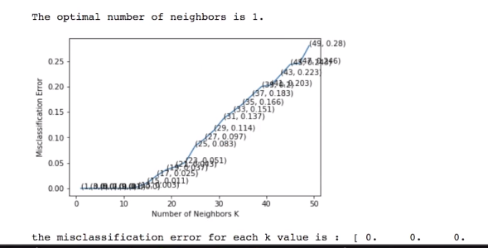

**Now we will use this optimal k and repeat same procedure.**

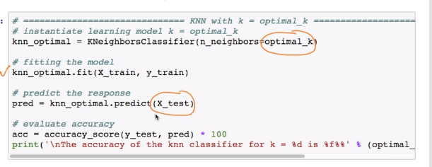

**And we got accuracy of 99.33%.**